## **EXPERIMENT NO. 7**

**Aim:** Develop a dashboard and reporting tool based on real time social media data.

**Theory:**

Power BI, developed by Microsoft, is a powerful tool for data visualization and business intelligence. It enables users to connect to various data sources, transform data, and create interactive visualizations to uncover insights and share them across teams or stakeholders.

**Input Data Sources**

Power BI supports a wide variety of data sources, including:

* **Structured Files**: Excel, CSV, XML, JSON
* **Databases**: SQL Server, PostgreSQL, MySQL, and others
* **Web Data**: Online services, APIs, and webpages
* **Cloud Sources**: Azure, Google Analytics, Salesforce, and more

**Steps to Build a Dashboard in Power BI**

**Step 1: Get Data**

* Navigate to the "Get Data" icon and choose the appropriate data source. In this case, we select the **Excel Workbook** option.
* Load the data tables by selecting them and clicking the **Load** button.

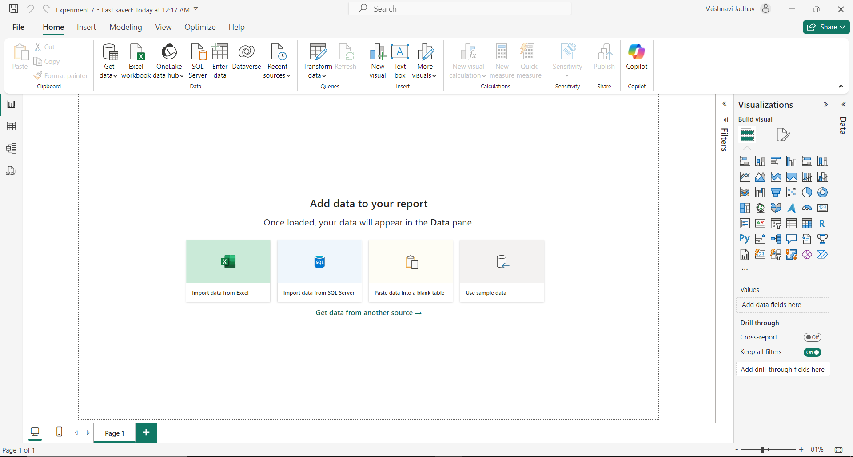

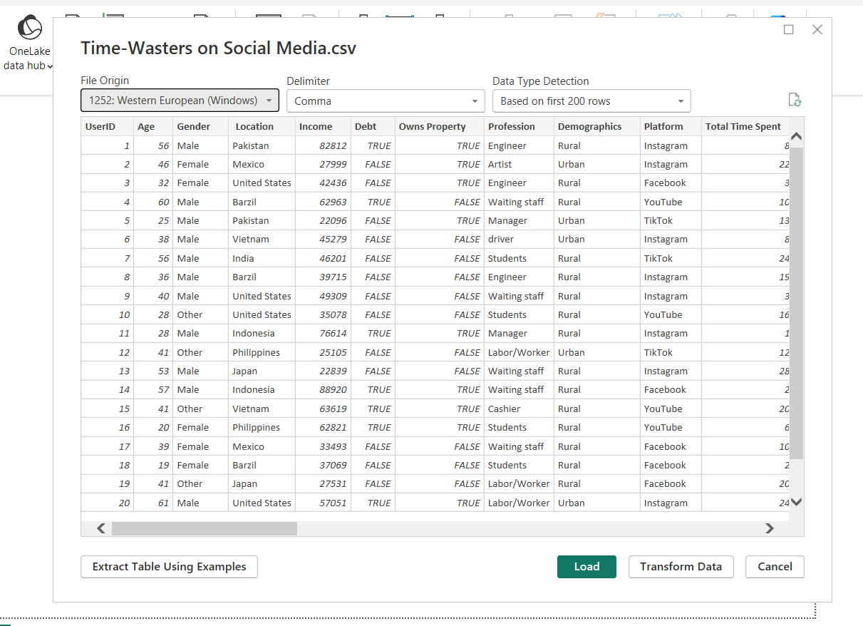

**Step 2: Explore the Power BI User Interface**

Power BI has three primary tabs:

1. **Report Tab**: The workspace for designing dashboards by adding and customizing visuals. This is where most of the work is done.

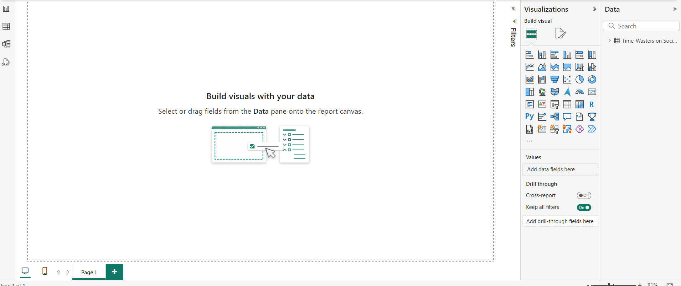

1. **Data Tab**: Displays all loaded data tables, allowing users to inspect and explore their contents.

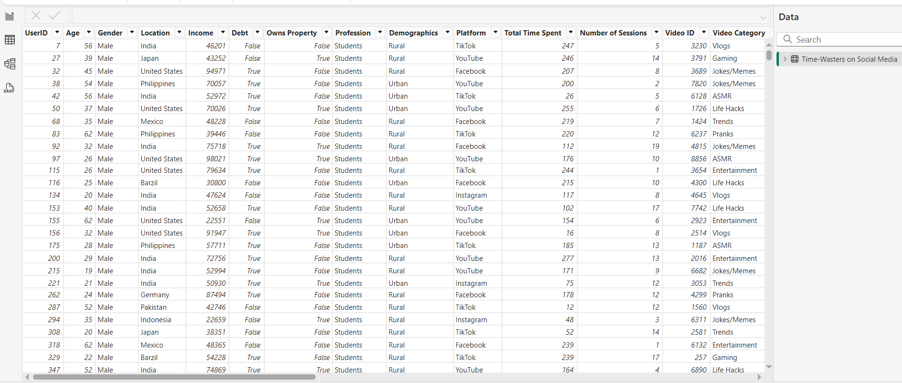

1. **Model Tab**: Visualizes relationships between tables. Since we only have one table there is no relationship between tables to display.

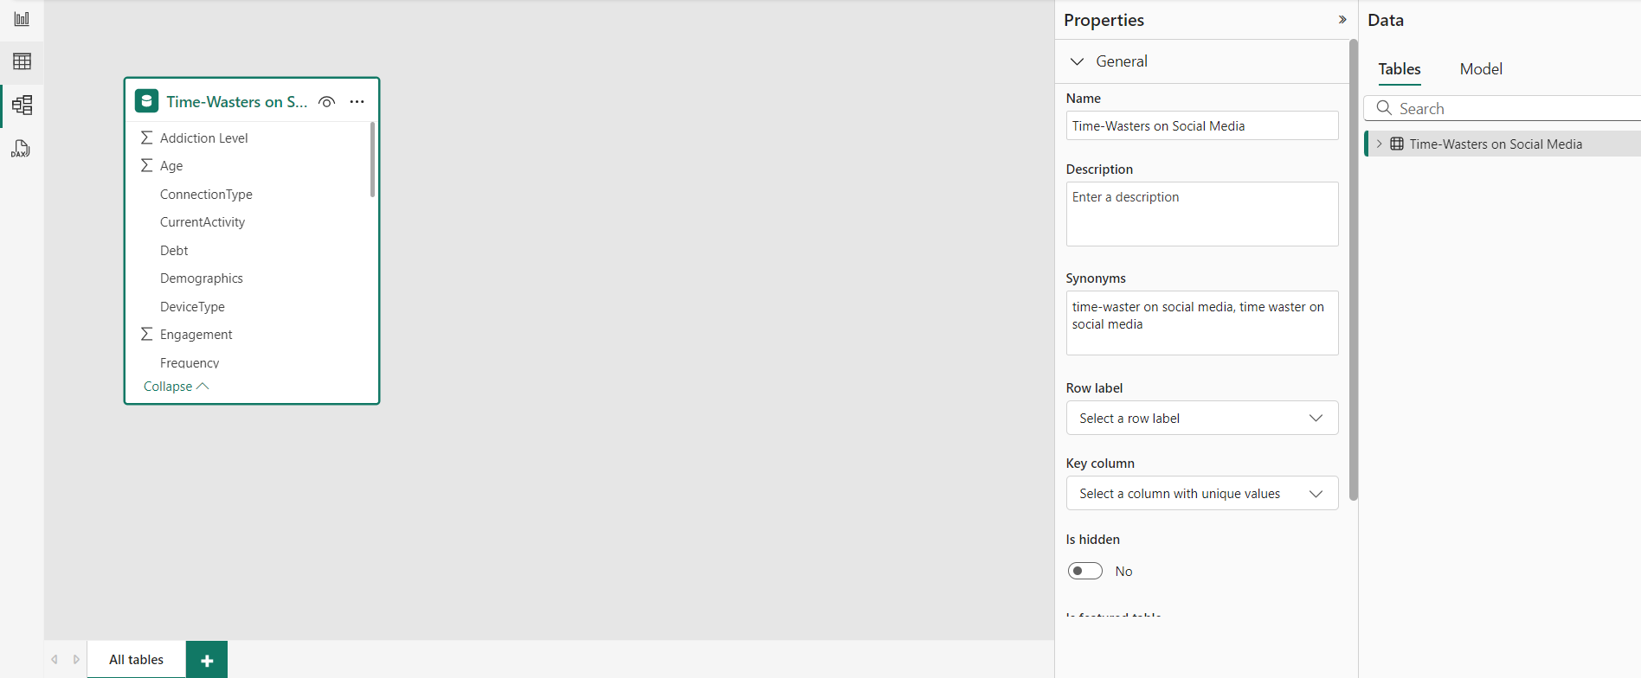

**Step 3: Create Visualizations**

* **Drag and Drop Visuals**: Power BI offers a range of visuals like bar charts, pie charts, cards, and tables, which can be added by simply dragging fields into the visual area.

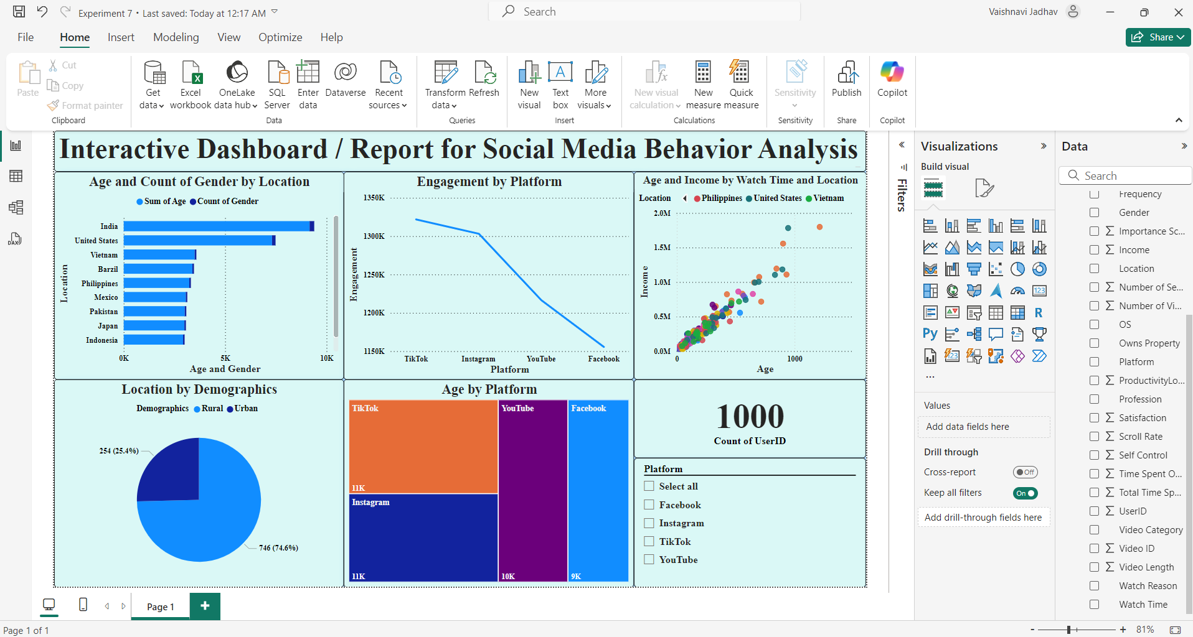

**Step 4:** Select YouTube in Platform Slicer to get YouTube data.

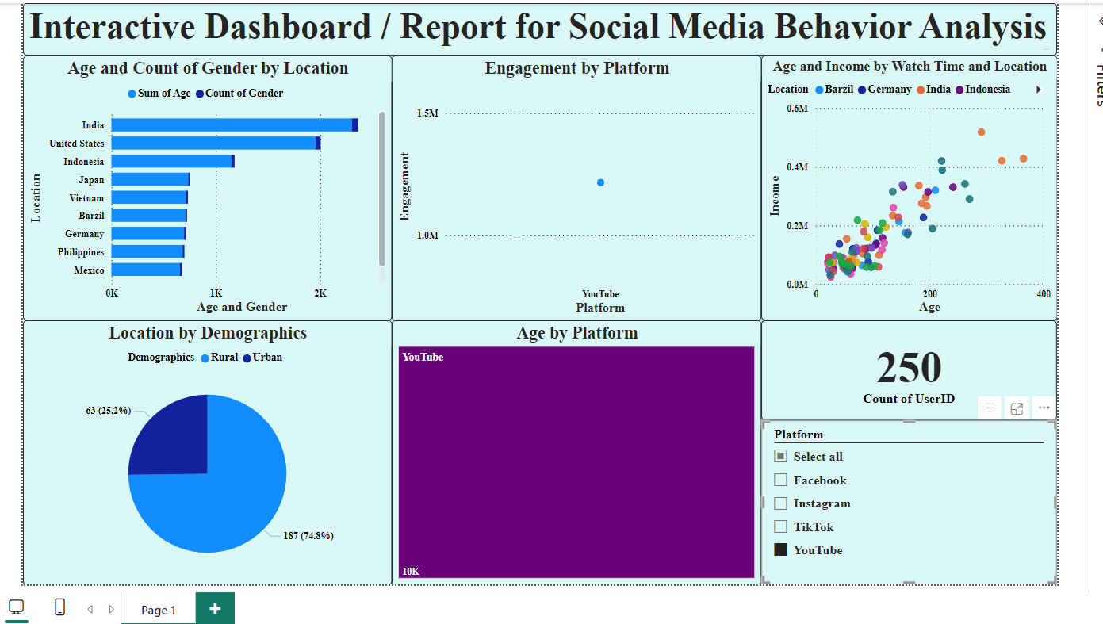

**Conclusion:**

Thus, successfully developed a dashboard using Power BI tool by Microsoft on social media data.